Multi threaded programming and Lambda expressions

Lab No. | Program / Experiment
1 | Write a Java program to create multiple threads and demonstrate different thread priorities using MIN_PRIORITY, NORM_PRIORITY, and MAX_PRIORITY.  class PriorityThread extends Thread {  public PriorityThread(String name) {  super(name);  }  @Override  public void run() {  System.out.println(getName() + " [Priority: " + getPriority() + "] is running.");  }  }  public class ThreadPriorities {  public static void main(String[] args) {  PriorityThread t1 = new PriorityThread("Thread-MIN");  PriorityThread t2 = new PriorityThread("Thread-NORM");  PriorityThread t3 = new PriorityThread("Thread-MAX");  t1.setPriority(Thread.MIN_PRIORITY);  t2.setPriority(Thread.NORM_PRIORITY);  t3.setPriority(Thread.MAX_PRIORITY);  t1.start();  t2.start();  t3.start();  }  }  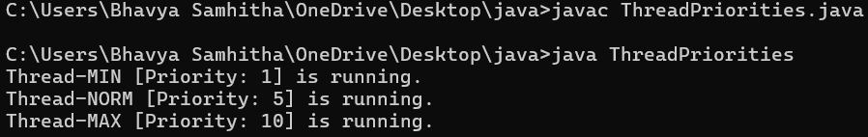
2 | Write a Java program to create three threads with different priorities and observe their execution order.  class WorkerThread extends Thread {  public WorkerThread(String name) {  super(name);  }  @Override  public void run() {  for (int i = 1; i <= 3; i++) {  System.out.println(getName() + " executing step " + i);  }  }  }  public class ExecutionOrder {  public static void main(String[] args) {  WorkerThread low = new WorkerThread("Low-Priority Thread");  WorkerThread mid = new WorkerThread("Mid-Priority Thread");  WorkerThread high = new WorkerThread("High-Priority Thread");  low.setPriority(Thread.MIN_PRIORITY);  mid.setPriority(Thread.NORM_PRIORITY);  high.setPriority(Thread.MAX_PRIORITY);  low.start();  mid.start();  high.start();  }  }  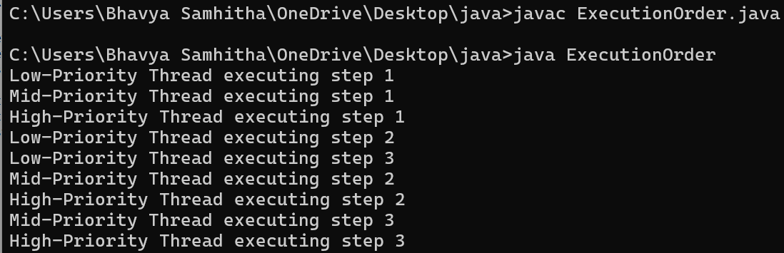
3 | Write a Java program to demonstrate synchronization using a synchronized method for accessing a shared counter.  class Counter {  private int count = 0;  public synchronized void increment() {  count++;  }  public int getCount() {  return count;  }  }  public class SynchronizedMethod {  public static void main(String[] args) throws InterruptedException {  Counter counter = new Counter();  Thread t1 = new Thread(() -> {  for (int i = 0; i < 1000; i++) counter.increment();  });  Thread t2 = new Thread(() -> {  for (int i = 0; i < 1000; i++) counter.increment();  });  t1.start();  t2.start();  t1.join();  t2.join();  System.out.println("Final Counter Value: " + counter.getCount());  }  }  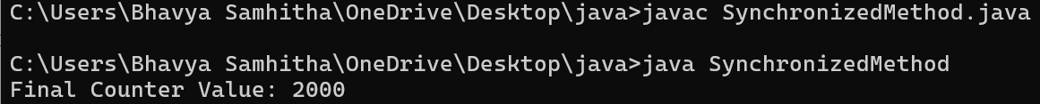
4 | Write a Java program to demonstrate synchronization using a synchronized block.  class SharedBuffer {  private int count = 0;  public void increment() {  synchronized (this) {  count++;  }  }  public int getCount() {  return count;  }  }  public class SynchronizedBlock {  public static void main(String[] args) throws InterruptedException {  SharedBuffer buffer = new SharedBuffer();  Thread t1 = new Thread(() -> {  for (int i = 0; i < 1000; i++) buffer.increment();  });  Thread t2 = new Thread(() -> {  for (int i = 0; i < 1000; i++) buffer.increment();  });  t1.start();  t2.start();  t1.join();  t2.join();  System.out.println("Final Buffer Count: " + buffer.getCount());  }  }  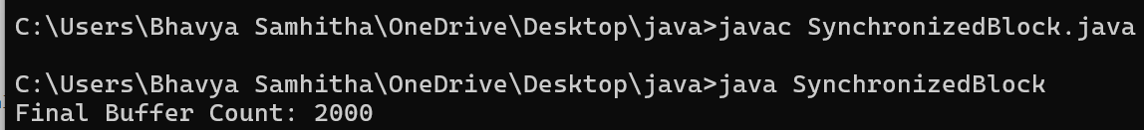
5 | Write a Java program to demonstrate a race condition and eliminate it using synchronization.  class UnsafeCounter {  int count = 0;  // Causes race condition without synchronization  public void increment() {  count++;  }  // Fixes race condition  public synchronized void safeIncrement() {  count++;  }  }  public class RaceCondition {  public static void main(String[] args) throws InterruptedException {  UnsafeCounter c1 = new UnsafeCounter();  // Demonstrating Race Condition  Thread t1 = new Thread(() -> { for (int i = 0; i < 10; i++) c1.increment(); });  Thread t2 = new Thread(() -> { for (int i = 0; i < 10; i++) c1.increment(); });  t1.start(); t2.start();  t1.join(); t2.join();  System.out.println("Without Synchronization (Race Condition): " + c1.count);  UnsafeCounter c2 = new UnsafeCounter();  // Demonstrating Synchronized Fix  Thread t3 = new Thread(() -> { for (int i = 0; i < 10; i++) c2.safeIncrement(); });  Thread t4 = new Thread(() -> { for (int i = 0; i < 10; i++) c2.safeIncrement(); });  t3.start(); t4.start();  t3.join(); t4.join();  System.out.println("With Synchronization (Race Condition Eliminated): " + c2.count);  }  }
6 | Write a Java program to implement a synchronized ticket-booking system where multiple threads attempt to book tickets simultaneously.  class TicketBookingSystem {  int seats = 1;  public synchronized void book(String name) {  if (seats > 0) {  System.out.println(name + " booked the ticket.");  seats--;  } else {  System.out.println(name + " failed: Housefull.");  }  }  }  public class TicketBooking {  public static void main(String[] args) {  TicketBookingSystem sys = new TicketBookingSystem();  new Thread(() -> sys.book("")).start();  new Thread(() -> sys.book("Bob")).start();  }  }  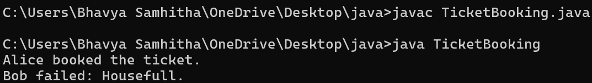
7 | Write a Java program to introduce lambda expressions by implementing a functional interface for addition, subtraction, multiplication, and division.  @FunctionalInterface  interface MathOp {  double compute(double a, double b);  }  public class ArithmeticLambda {  public static void main(String[] args) {  MathOp add = (a, b) -> a + b;  MathOp sub = (a, b) -> a - b;  MathOp mul = (a, b) -> a * b;  MathOp div = (a, b) -> a / b;  System.out.println("Add: " + add.compute(10, 5));  System.out.println("Sub: " + sub.compute(10, 5));  System.out.println("Mul: " + mul.compute(10, 5));  System.out.println("Div: " + div.compute(10, 5));  }  }  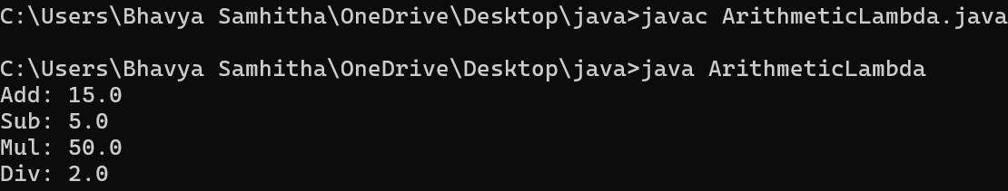
8 | Write a Java program to demonstrate a lambda expression with a single parameter and multiple parameters.  interface SingleParam {  void print(String msg);  }  interface MultiParam {  int add(int a, int b);  }  public class LambdaParams {  public static void main(String[] args) {  SingleParam p1 = msg -> System.out.println(msg);  p1.print("Hello Lambda!");  MultiParam p2 = (a, b) -> a + b;  System.out.println("Sum: " + p2.add(10, 20));  }  }  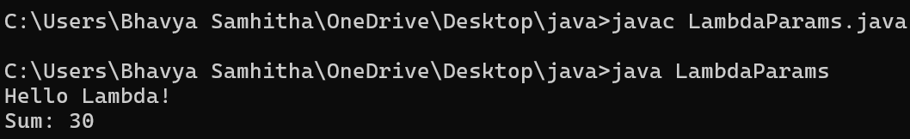
9 | Write a Java program to demonstrate a block lambda expression containing multiple statements.  interface Factorial {  int calc(int n);  }  public class BlockLambda {  public static void main(String[] args) {  Factorial f = (n) -> {  int fact = 1;  for (int i = 1; i <= n; i++) {  fact *= i;  }  return fact;  };  System.out.println("Factorial of 5: " + f.calc(5));  }  }  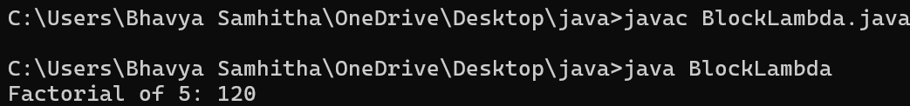
10 | Write a Java program using a block lambda expression to find the largest of two numbers and return the result.  interface MaxFinder {  int getMax(int a, int b);  }  public class LargestNumber {  public static void main(String[] args) {  MaxFinder max = (a, b) -> {  if (a > b) return a;  else return b;  };  System.out.println("Largest: " + max.getMax(15, 25));  }  }  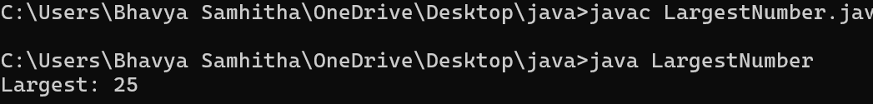
11 | Write a Java program to create a generic functional interface and implement it using lambda expressions for different data types.  interface Printer<T> {  void print(T val);  }  public class GenericInterface {  public static void main(String[] args) {  Printer<Integer> intPrint = val -> System.out.println("Int: " + val);  Printer<String> strPrint = val -> System.out.println("String: " + val);  intPrint.print(100);  strPrint.print("Hello Java");  }  }  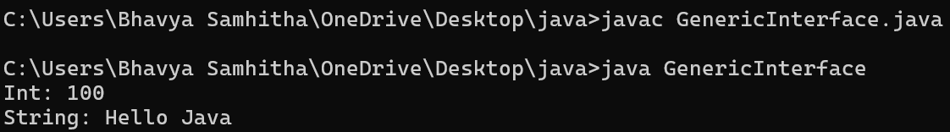
12 | Write a Java program to create a generic functional interface that accepts two values and performs an operation using a lambda expression.  interface Operation<T> {  T operate(T a, T b);  }  public class TwoValueGeneric {  public static void main(String[] args) {  Operation<Integer> add = (a, b) -> a + b;  Operation<String> concat = (a, b) -> a + b;  System.out.println("Sum: " + add.operate(5, 10));  System.out.println("Text: " + concat.operate("Java ", "8"));  }  }  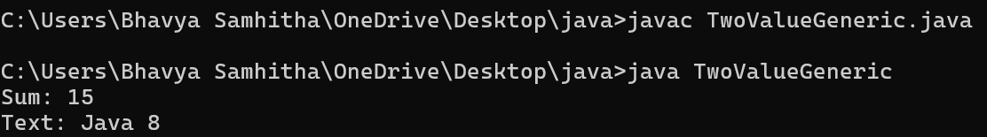
13 | Write a Java program to use lambda expressions to display and filter elements of an ArrayList.  import java.util.ArrayList;  public class ArrayListLambda {  public static void main(String[] args) {  ArrayList<Integer> list = new ArrayList<>();  list.add(5);  list.add(12);  list.add(8);  list.add(20);  System.out.print("All elements: ");  list.forEach(n -> System.out.print(n + " "));  System.out.print("\nFiltered (> 10): ");  list.stream().filter(n -> n > 10).forEach(n -> System.out.print(n + " "));  }  }  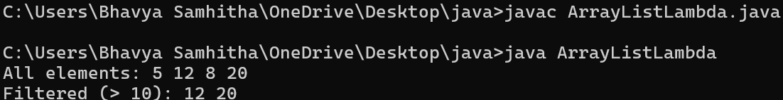
14 | Write a Java program to sort a list of integers and strings using lambda expressions.  import java.util.ArrayList;  import java.util.Collections;  public class SortingLambda {  public static void main(String[] args) {  ArrayList<Integer> nums = new ArrayList<>();  nums.add(30); nums.add(10); nums.add(20);  nums.sort((a, b) -> a.compareTo(b));  System.out.println("Sorted Numbers: " + nums);  ArrayList<String> words = new ArrayList<>();  words.add("Banana"); words.add("Apple"); words.add("Cherry");  words.sort((a, b) -> a.compareTo(b));  System.out.println("Sorted Words: " + words);  }  }  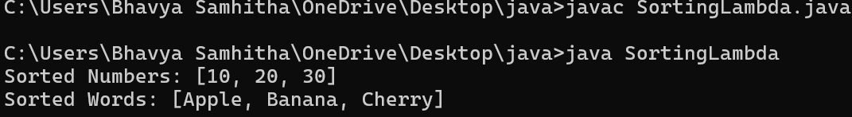
15 | Write a Java program to create and execute a thread using a lambda expression.  public class ThreadLambda {  public static void main(String[] args) {  Runnable task = () -> {  for (int i = 1; i <= 3; i++) {  System.out.println("Lambda Thread running iteration: " + i);  }  };  Thread thread = new Thread(task);  thread.start();  }  }  

